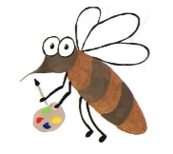

Lyng Primary School Knowledge Organiser

Art

Spring 2 and Summer 1

Year 3

Topic: Art

|  |  |
| --- | --- |
| Vocabulary | |
| **Spelling** | **definition** |
| **architecture** | The architecture of a building is the **style** in which it is **designed and constructed.** |
| **column** | A column is **a tall,** often decorated **cylinder of stone** which is built to honour someone or forms part of a building. |
| **describe** | If you describe a person, object, event, or situation, you say **what they are like or what happened.** |
| **design** | When you **plan** and **prepare** something, and decide on all the **details of it.** |
| **geometric** | Geometric or geometrical patterns or **shapes** consist of **regular shapes or lines.** |
| **pattern** | A pattern is an **arrangement of lines or shapes,** especially a design in which the same shape is **repeated** at regular intervals over a surface. |
| **replicate** | If you replicate someone's experiment, work, or research, you do it yourself in **exactly the same way.** |
| **structure** | The structure of something is the **way** in which it is **made, built, or organized.** |

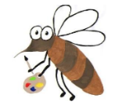

**Background information for parents and teachers**

Children will study Greek pottery, Greek architecture and columns. They will describe the images that are seen and the style of them. They will replicate some of the patterns found on the pottery, sketch the Greek column styles and create their own Greek building.

**Spring 2**

Greek vases

Greek architecture

Greek column designs

|  |
| --- |
| Skills and techniques |
| * **Develop ideas** from starting points throughout the curriculum. * **Collect information**, sketches and resources. * **Comment** on artworks using **visual language**. * **Create** and **combine shapes** to create recognisable forms (e.g. shapes made from nets or solid materials). * Use **shading** to show **light** and **shadow**. * **Replicate** some of the techniques used by notable artists, artisans and designers. * **Create original pieces** that are **influenced** by studies of others. |

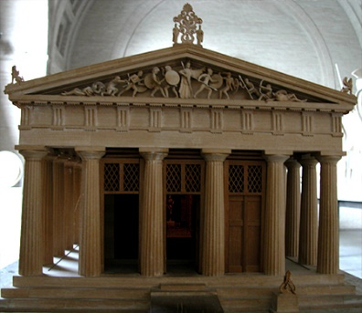

**Greek Column Designs**

**Y3 knowledge**

Children will describe Greek architecture to each other so their partner can draw it without seeing. This will require specific descriptive artistic vocabulary to be used. The children will also replicate the style of the Greek columns using chalk and then create their own 3D model of a Greek building.

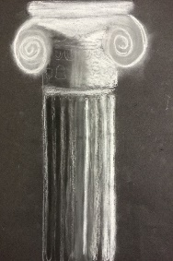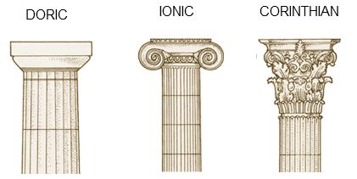

Agreed outcome:

Study Greek vases.

Group sketch of Greek building

Chalk drawing of columns

3D model of Greek building